**ECG-BASED BIOMETRIC AUTHENTICATION USING EMPIRICAL MODE DECOMPOSITION AND SUPPORT VECTOR MACHINES**

**Abstract**—Electrocardiogram (ECG) is an electric signal of cardiac activity posing highly discriminative properties related to human recognition. ECG based authentication has gained much success in recent times however discriminant feature extraction and efficient pattern classification still encounter numerous challenges. This paper proposed a novel methodology for ECG based biometric authentication system. Proposed method first denoise single lead raw ECG signal through empirical mode decomposition (EMD). Region of interest from ECG signals having maximum characteristic information related to subject’s recognition is also extracted through EMD. Next, feature extraction is performed by combination of five features from statistical, time and frequency domains. Finally, selected features were categorized with range of different classification methods such as Support Vector Machines (SVM), K-nearest neighbor (KNN) and Decision Tree (DT).

**Keywords—**Biomedical recognition system, Electrocardiogram, Biometric authentication, Empirical mode decomposition, Support vector machines, Feature extraction.

**Existing system-** Biometric features are the characteristics that are unique to a single individual that acts as a basis for the identification of that individual from the rest of the population. Out of all the medical signals, ECG is the ultimate signal used for this purpose because it is unique for every individual and this uniqueness can be exploited by looking at different features of ECG. Electrical currents are generated at the Sinoatrial node (SA) node of heart and travel down to the Atrioventricular (AV) node and spread not only within the heart but also throughout the body[3]. These electrical currents known as the ECG can be measured with the help of surface electrodes. ECG signal consists of P wave that represents atrial depolarization or more commonly known as contraction of atria. The QRS complex in ECG signal shows ventricular depolarization or ventricular contraction and T wave represents ventricular repolarization or ventricular relaxation. Normal ECG signal is shown in Fig. 1.

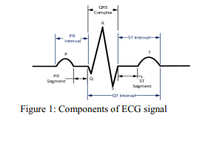

**Disadvantages:**

* It is most difficult to counterfeit as compared to fingerprint of a person which can be forged , voice recording of a person in his absence can be used and
* Iris images can be used in iris based recognition but such tactics cannot be used in ECG biometrics

**Proposed method:**

In this work, we applied empirical mode decomposition (EMD) for removing artifacts and extraction of region of interest from raw ECG signal. Afterwards, feature extraction is performed by extracting useful and representative features of time, frequency and statistical domain. Selected five features were analyzed through variety of classification methods and SVM based classifier achieved best performance. Rest of the article is structured as follows.block diagram illustrates detailed of the proposed ECG based biometric classification system. Data acquired from ECG electrodes is preprocessed through EMD. EMD decomposes input signal into sub-components called intrinsic mode functions (IMFs). Region of interest is extracted from ECG signal that carry discriminative information about every individual/subject. Redundant information and noise are discarded by removing those signal components from resultant preprocessed signal.

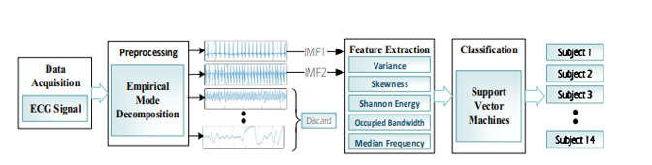

Figure 2: Sketch of the proposed ECG-based Biometric System

**Advantages:**

* Vector Machines (SVM) is widely applied as a best choice classifier for biomedical signal analysis applications.
* Empirical mode decomposition (EMD) is a recent and adaptive method that expands a signal into a compression of Intrinsic Mode Functions (IMFs) [24- 26].
* Bandwidth containing of the total integrated power of the transmitted spectrum, centered on the assigned channel frequency.

**Applications:**

1. Applied in DSP applications.

2. ECG Peak Detection.

3. Bio-Medical Signal Processing.

4. Image Processing

**Software requirements:**

• MatlabR2020a.

**Hardware requirements:**

**Operating Systems:**

• Windows 10

**•** Windows 7 Service Pack 1

• Windows Server 2019 & 2016.

**Processors:**

Minimum: Any Intel or AMD x86-64 processor.

Recommended: Any Intel or AMD x86-64 processor with four logical cores and AVX2 instruction set support.

**Disk:**

Minimum: 2.9 GB of HDD space for MATLAB only, 5-8 GB for a typical installation.

Recommended: An SSD is recommended a full installation of all Math Works products may take up to 29 GB of disk space.

**RAM:** Minimum 4 GB but recommended 8 GB.